Design Document

Date : 20/02/2018

Restaurant Management System

Software Engineering(IT350)

Submitted by : Akriti Kumari (15IT107)

Submitted to :Ms.Raksha R Nadgir

Table of Contents

- Use Case Diagram 3

- Use Case Description 5

- Domain model 8

- System sequence diagram 9

- Use Case Realization 12

- Design Class Diagram 13

- Architecture Diagram 14

1. Use case diagram:
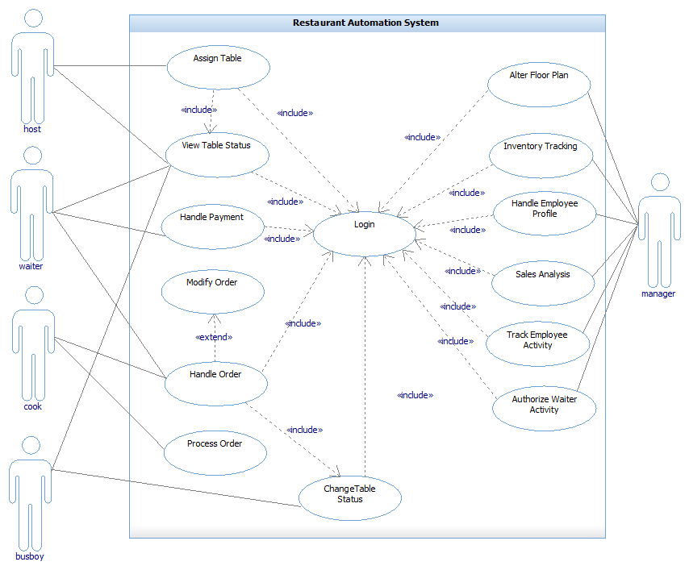
e case diagram:
Use Case Diagram

Description :
- Assign Table: The host will be able to assign a table to a waiter once he has assigned the same to a person.
- View Table Status: The host, waiter and bus boy would be able to see the status of each table with the following color code.
- Change Table Status: The host would be able to assign tables and change their status from green to yellow. The waiter would be able to change the table status .
- Handle Order: The waiter would be able to browse the menu of the items available and place order for each table based on the persons choice. The cook would be able to view these orders.
- Handle Payment: The waiter handles the payment made by the person for the placed order.
- Process Order: The cook would be able to process the order and notify the appropriate waiter once the food is ready.
- Modify order: Once the waiter has placed the order, he/she can modify it by adding or removing items if the person requests for it.
- Handle Employee Profile: The manager would be able to create a new profile when a new employee joins the restaurant and can modify their status anytime he wants.

2. Use Case Description:
Use Case Name | Handle order
Brief description | The waiter handles the order placed by the person.
Primary actors | Waiter
Second actors | Cook
Pre Conditions | The table must be occupied by the Person.
Main flow | - Include (Login).  - The system displays the list of tables assigned to the waiter.  - Include (Change Table Status).  - The Person specifies the items he would like to have.  - The waiter starts a new order.  - The waiter selects the “add item” option in the system.  - The system generates a list of categories available in the menu.  - The waiter selects the specific category under which he could find the specified item.  - The waiter adds the item to the order.  - The waiter repeats step 7 to 10 until all the items have been added to the order.  - The waiter places the order.  - The system adds the order to the order queue.  - The system notifies the cook that a new order is added to the queue. At any point, the waiter modifies the placed order as per the Person’s request.
Post Conditions | None
Non-Functional Requirements | The order queue should get updated once a new order is updated.

Use Case Name | Process Order
Brief description | The cook would be able to process the order and notify the appropriate waiter once the food is ready.
Primary actors | Cook
Second actors | None
Pre Conditions | Order is added to the order queue.
Main flow | - Include (Login).  - Includes (View order)  - The cook selects the first order in the order queue.  - The cook changes the order status to ready once the food items have been cooked.
Post Conditions | The system notifies the waiter that the order is ready.

Use Case Name | Assign table
Brief description | The host can assign un-occupied tables to Persons.
Primary actors | Host
Second actors | None

Use Case Name | Handle Payment
Brief description | The waiter handles the payment made by the Person for the placed order.
Primary actors | Waiter
Second actors | None

Use Case Name | Change Table Status
Brief description | The host, waiter, busboy can change the status of the table from free to occupied, occupied to dirty, dirty to free respectively.
Primary actors | Busboy, Waiter, Host
Second actors | None

Use Case Name | Handle Employee Profile
Brief description | The manager creates a new profile when a new employee joins the restaurant as well as modify the profile of other employees when needed.
Primary actors | Manager
Second actors | None

Use Case Name | Modify Order
Brief description Segment 1 | The waiter modifies the order if the Person requests for it.
Primary actors | Waiter
Second actors | None
Segment 1 Pre Conditions | The order is placed by the waiter.
Segment 1 flow | The waiter adds or removes items from the placed order.
Segment 1 Post Conditions | The order has been modified.

3. Domain Model:
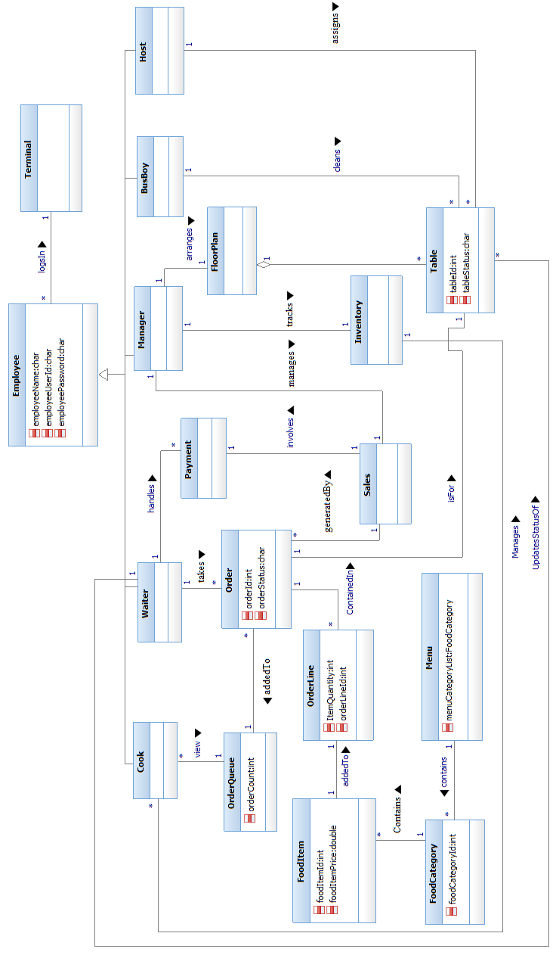

4. System Sequence Diagram:
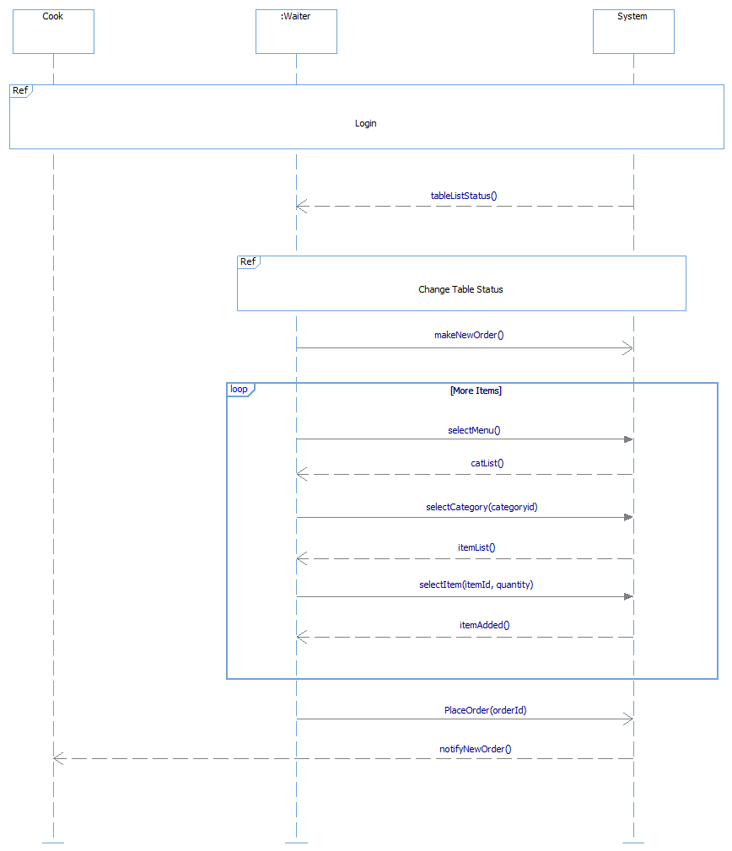

Login :

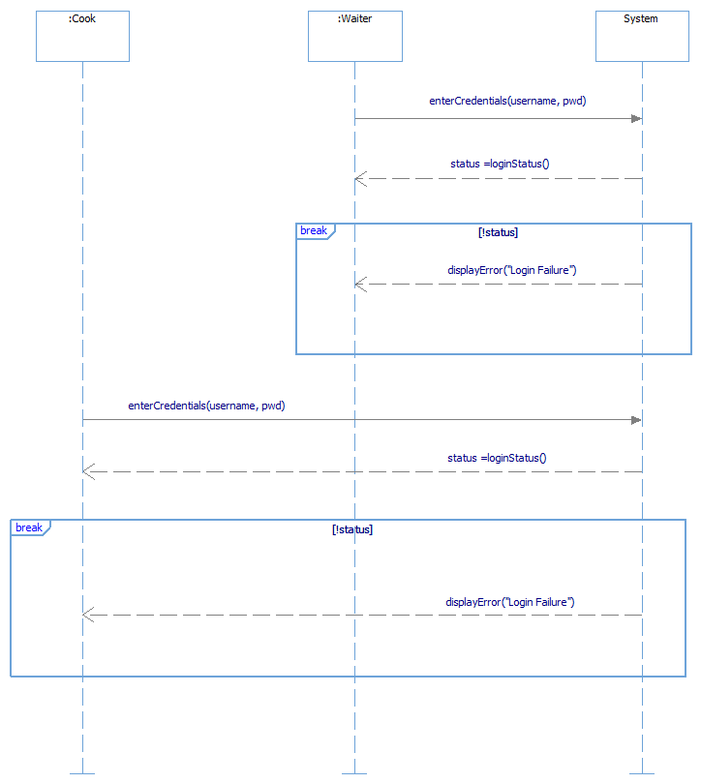

Change Table Status:

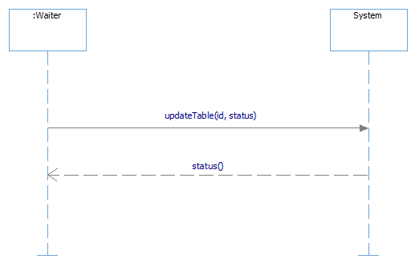

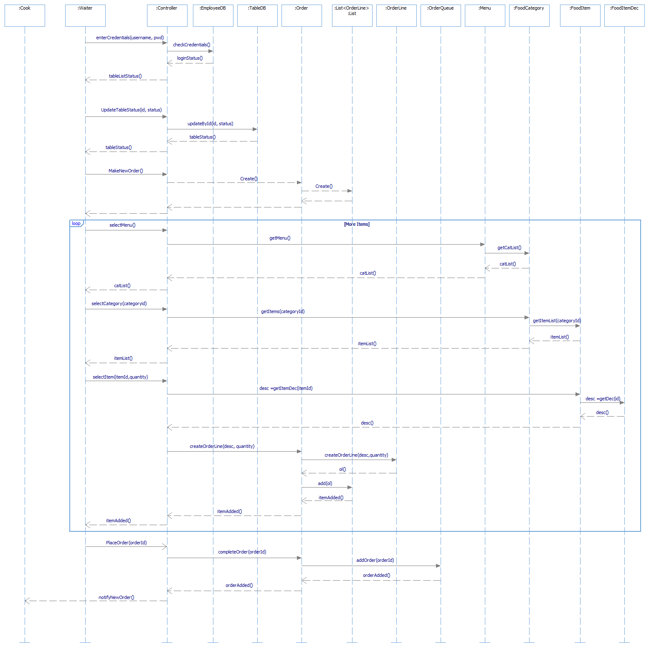
5. Use Case Realization :

6. Design Class Diagram :

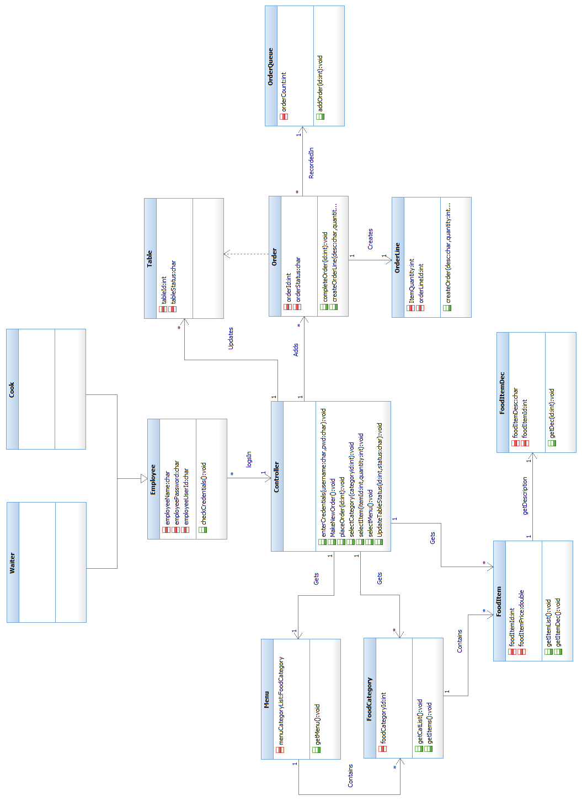

7. Architecture Diagram :
